Priority Non Pre emptive

#include <stdio.h>
#include <stdlib.h>

struct Process {
int at, bt, ct, tat, wt, priority;
int completed;
};

int main() {
int n, i;
printf("Enter the number of processes:");
scanf("%d", &n);
struct Process pro[n];
for(i = 0; i < n; i++) {
printf("Enter AT, BT and Priority for process %d:", i+1);
scanf("%d %d %d", &pro[i].at, &pro[i].bt, &pro[i].priority);
pro[i].completed = 0;
}
int completed = 0, shortest=-1, time=0, cp;
while(completed < n) {
shortest = -1;
cp = 100;
for(i = 0; i < n; i++) {
if(pro[i].at <= time && pro[i].priority < cp && pro[i].completed == 0) {
shortest = i;
cp = pro[i].priority;
}
}
if(shortest != -1) {
time += pro[shortest].bt;
completed++;
pro[shortest].ct = time;
pro[shortest].completed = 1;
pro[shortest].tat = pro[shortest].ct - pro[shortest].at;
pro[shortest].wt = pro[shortest].tat - pro[shortest].bt;
}
else{
time++;
}
}
printf("Process AT \t BT \t Priority CT \t TAT \t WT \n");
for(i = 0; i < n; i++) {
printf("%d \t %d \t %d \t %d \t %d \t %d \t %d \n", i+1, pro[i].at, pro[i].bt, pro[i].priority, pro[i].ct, pro[i].tat, pro[i].wt);
}
}

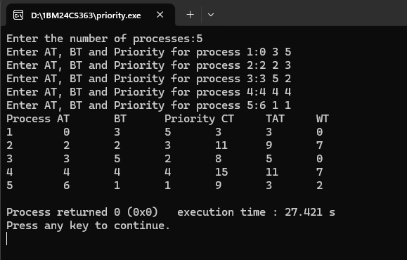

Priority Pre emptive

#include <stdio.h>
#include <stdlib.h>

struct Process {
int at, bt, ct, tat, wt, priority, bt_left;
};

void main() {
int n, i;
printf("Enter the number of processes:");
scanf("%d", &n);
struct Process pro[n];
for(i = 0; i < n; i++) {
printf("Enter AT, BT and Priority for process %d:", i+1);
scanf("%d %d %d", &pro[i].at, &pro[i].bt, &pro[i].priority);
pro[i].bt_left = pro[i].bt;
}
int time=0, shortest=-1, cp, completed=0;
while(completed < n) {
shortest = -1;
cp = 100;
for(i = 0; i < n; i++) {
if(pro[i].at <= time && pro[i].bt_left != 0 && pro[i].priority < cp) {
shortest = i;
cp = pro[i].priority;
}
}
if(shortest != -1) {
pro[shortest].bt_left--;
time++;
if(pro[shortest].bt_left == 0) {
completed++;
pro[shortest].ct = time;
pro[shortest].tat = pro[shortest].ct - pro[shortest].at;
pro[shortest].wt = pro[shortest].tat - pro[shortest].bt;
}
}
else {
time++;
}
}
printf("Process AT \t BT \t Priority CT \t TAT \t WT \n");
for(i = 0; i < n; i++) {
printf("%d \t %d \t %d \t %d \t %d \t %d \t %d \n", i+1, pro[i].at, pro[i].bt, pro[i].priority, pro[i].ct, pro[i].tat, pro[i].wt);
}
}

